**Movie Ticket Booking Application**

A Project Report

### Submitted

*In partial fulfillment of the requirements for the award of the degree*

### BACHELOR OF TECHNOLOGY

**In**

### COMPUTER SCIENCE and ENGINEERING

By

Sri Krishna Teja Aradhyula (201FA04237)

Arumalla Kushal Chowdary (201FA04270)

Under the Guidance of

### Dr.M.Umadevi

### Associative Professor



**DEPARTMENT OF COMPUTER SCIENCE & ENGINEERING**

## VIGNAN’S FOUNDATION FOR SCIENCE, TECHNOLOGY AND RESEARCH

(Deemed to be University)

Vadlamudi, Guntur -522213, INDIA.

June



**DEPARTMENT OF COMPUTER SCIENCE & ENGINEERING**

**CERTIFICATE**

This is to certify that the report entitled “**Movie Ticket Booking Application”** is submitted by **“SriKrishnaTejaAradhyula(201FA04237), Arumalla Kushal Chowdary(201FA04270)”**in the partial fulfillment of course work of an interdisciplinary project, carried out in the department of CSE, VFSTR Deemed to be University.

Name of the Guide External Examiner Dr. K. V. Krishna Kishore

### Dr.M.Umadevi

### Associative Professor

HOD, CSE

Dean, School of Comp. & Info

**DECLARATION**

I hereby declare that the project entitled “**Movie Ticket Booking Application**” submitted for the “**Department of Computer Science and Engineering**”. This dissertation is our original work and the project has not formed the basis for the award of any degree, associate-ship and fellowship or any other similar titles and no part of it has been published or sent for publication at the time of submission.

By

Sri Krishna Teja Aradhyula (201FA04237)

Arumalla Kushal Chowdary (201FA04270)

Date:27-11-2023

**ACKNOWLEDGEMENT**

This project program is a golden opportunity for learning and self-development. Consider ourselves very lucky and honored to have so many wonderful people lead us through in the completion of this project.

We extend our sincere appreciation to the Project Guide **Dr. M. Umadevi**, for grantingus permission to undertake the Program and for his continuous support and cooperation throughout the duration of our project.

We express our gratitude to the Project Coordinator **Ms. V. Anusha**, for permitting us to undertake the Program and for the help and cooperation throughout the course of our project Program.

It is a great pleasure for us to express our sincere thanks to **Dr. K. V. Krishna Kishore, HOD, CSE and Dean, School of Computing & Informatics** of VFSTR Deemed to be a university, for providing us with an opportunity to do our Project Program.

We extend our wholehearted gratitude to all our faculty members, programmers, and technicians of the Department of Computer Science and Engineering who helped using our academics throughout the course.

Finally, we wish to express thanks to our family members for the love and affection overseas and cheerful depositions, which are vital for sustaining the effort required for completing this work

With Sincere regards,

Sri Krishna Teja Aradhyula (201FA04237)

Arumalla Kushal Chowdary (201FA04270)

**ABSTRACT**

The Multi-User Movie and Event Ticket Booking Application is a sophisticated platform designed to simplify and enhance the process of booking movie tickets across different theaters. This user-friendly application caters to both regular users and administrators, providing efficient management of movie bookings, theater details, and movie schedules.

The comprehensive database schema ensures secure authentication, streamlined management, efficient booking, and insightful event tracking. The Flask API serves as the backbone of the system, featuring endpoints for user authentication, theater management, movie scheduling, and user bookings. With role-based access control, the application distinguishes between Admins, Store Managers, and Customers, ensuring a secure and seamless experience.

The interface is designed for clarity, facilitating easy navigation for users with distinct roles. The application leverages a stack of technologies, including Vue.js, Flask, HTML, CSS, Bootstrap, Redis, Celery, Chart.js, JWT, and SQLite. Robust user management, including signup and login, is implemented using Flask-Security or JWT-based tokens. CRUD operations for categories and products, a flexible purchasing system, and scheduled backend jobs for data synchronization and alerts contribute to the efficiency of the platform.

Admins enjoy the privilege of managing theaters and movies with multilingual support and customizations. The booking functionality allows users to reserve multiple tickets, while Admins can control bookings for full movies. The system supports exporting theater details via CSV, triggered by users, with caching strategies optimizing performance. In summary, this application provides a modular and user-friendly platform with secure interactions, role-based access control, efficient management features, customization options for theaters and movies, booking capabilities, export functionalities, reporting features, alerts, and API performance enhancements. The architecture is designed for modularity and usability, meeting the diverse needs of various user roles.

# CONTENTS

|  |  |
| --- | --- |
| **TITLE** | **PAGENO** |
| DECLARATION | i |
| ACKNOWLEDGEMENT | ii |
| ABSTRACT | iii |
| LIST OF FIGURES | vi |
| 1. INTRODUCTION    1. Introduction of the project    2. Background review of the state of the art in the releva field    3. The problem addressed in the project    4. Objective of the proposed projects    5. The Adopted approach | 2  nt 2  3  3  4 |
| 1. METHODS    1. System Design and Implementation Challenges    2. Time Constraints    3. Required knowledge Base    4. Required hardware and software tools    5. Existing standards impacting the system design    6. Regulatory Issues    7. Existing technology Limitations | 6  7  7  7  8  8  8 |
| 1. USE OF STANDARDS    1. Standardized Network Technologies    2. Standardized security mechanisms and protocols    3. Standardized software Development Tools and Environments    4. Standardized software Engineering practices 2. EXPERIMENT / PRODUCT RESULTS    1. Functionality Testing    2. User Satisfaction    3. Performance Metrices    4. Bug and Issue Tracking    5. Security Assessment    6. Scalability testing    7. Compliance with standards    8. Results       * Database schema       * Screen shots | 10  10  10  10  13  13  14  14  14  14  15  15  16  16 |

|  |  |
| --- | --- |
| 1. CONSTRAINTS 2. COST AND SUSTAINABILITY ANALYSIS    1. Economic Considerations    2. Environment Considerations    3. Social (Equity) Considerations 3. CONCLUSIONS / SUMMARY    1. Solution proposed    2. Main Results    3. Significant of the Project    4. comparison with other Existing Solutions    5. Future Directions 4. REFERENCES | 23  28  29  29  30  32  32  33  33  33  35 |

**List of Figures**

Figure 1: Database Schema 16

Figure 2: Landing Page 17

Figure 3: Admin Login Page 17

Figure 4: Admin Home Page 18

Figure 5: Create Theatre Page 18

Figure 6: Create Movie Page 19

Figure 7: Admin Summery Page 19

Figure 8: User Register Page 20

Figure 9: User Login Page 20

Figure 10: User Home Page 21

Figure 11: Booking Page 21

Figure 12: Booking Details Page 22

**CHAPTER-1:**

**INTRODUCTION**

**1.1 Introduction of the project**

The online movie ticket booking industry has witnessed significant growth in recent years. This is due in part to the increasing popularity of online shopping and the convenience it offers. However, many existing online booking systems are complex and difficult to use, and they often charge high fees.

The Multi-User Movie Ticket Booking Application is a comprehensive platform designed to facilitate the seamless booking of movie tickets for various movies in different theatres. This user-friendly application allows both regular users and an admin to efficiently manage movie bookings, theatre details, and movie schedules. With its intuitive interface and robust features, this app aims to enhance the movie-going experience for users while simplifying theatre and movie management for administrators.

This project aims to develop a user-friendly and affordable online movie ticket booking system that addresses the limitations of existing systems. The proposed system will be easy to use for both regular users and administrators, and it will offer a variety of features that make it a convenient and cost-effective way to book movie tickets.

1.2 Background review of the state of the art in the relevant field

The entertainment industry has undergone a profound transformation with the advent of digital technologies. One of the key areas that has witnessed significant changes is the way people book movie tickets. Gone are the days of waiting in long queues at the cinema. Today, moviegoers prefer the convenience of booking tickets online or via mobile applications. This shift in consumer behavior has created a demand for innovative and user-friendly platforms for movie ticket booking.

The Multi-User Movie Ticket Booking Application is a response to this demand. It is designed to provide a comprehensive and seamless platform for booking movie tickets, catering to a diverse audience of regular users and administrators. Leveraging modern technologies and design principles, this application aims to not only streamline the movie ticket booking process but also enhance the overall movie-going experience.

**1.3 The problem addressed in the project**

The traditional process of purchasing movie tickets has been plagued by inefficiencies and inconveniences. Movie enthusiasts have had to contend with long queues, limited availability of tickets, and the challenge of keeping track of movie schedules and theatre details. These issues have often led to frustrated customers and missed opportunities.

The Multi-User Movie Ticket Booking Application addresses these problems head-on. It seeks to simplify the ticket booking process, make it more efficient, and ensure that users have easy access to information about movie schedules and theatre details. By doing so, the application aims to eliminate the pain points of traditional ticket booking and offer a user-friendly alternative.

This project aims to develop a user-friendly and affordable online movie ticket booking system that addresses the limitations of existing systems. The proposed system will be easy to use for both regular users and administrators, and it will offer a variety of features that make it a convenient and cost-effective way to book movie tickets.

**1.4 Objective of the proposed projects**

The main objectives of this project are as follows:

1. User-Friendly Movie Ticket Booking: Develop a user-friendly and intuitive application that allows users to easily browse, select, and book movie tickets.
2. Secure User Authentication: Implement a robust user authentication system to ensure that only authorized users can access the platform. This includes both regular users and administrators.
3. Role-Based Access Control (RBAC): Create a role-based access control system that distinguishes between Admin, Store Manager, and Customer roles. Each role has distinct privileges and responsibilities within the application.
4. Efficient Management of Theatre Details: Provide administrators with tools to efficiently manage theatre information, including creation, editing, and removal. Support multilingual content for a diverse user base.
5. Movie Schedule Management: Enable administrators to manage movie schedules, allowing them to customize showtimes and provide users with up-to-date information.
6. Booking Functionality: Develop a booking system that allows users to reserve tickets for multiple movies in a single transaction. Administrators should have the capability to halt bookings for full movies.
7. Export Options and Reporting Features: Implement features that allow users and administrators to export theatre details via CSV and generate reports. Provide insights into booking trends and movie performance.
8. Performance Optimization: Utilize caching techniques to optimize the application's performance, ensuring a smooth and responsive user experience.
9. Modularity and Usability: Design the application architecture with modularity in mind, making it easy to expand and adapt to changing user needs and technological advancements.

**1.5 The adopted approach**

To achieve these objectives, the project leverages a robust technology stack:

* Vue.js is used for the frontend, providing a dynamic and responsive user interface.
* Flask serves as the core framework for the backend, enabling efficient data processing and management.
* HTML and CSS are employed for web design, ensuring a visually appealing and user-friendly interface.
* Bootstrap aids in creating a responsive and mobile-friendly design.
* Redis is used for caching to optimize data access and application performance.
* Celery is employed for task scheduling, facilitating operations like data synchronization and email alerts.
* JWT (JSON Web Tokens) ensures secure user authentication and authorization.
* SQLite is used as the database system for data storage.

This approach blends modern web technologies with industry-standard practices to create a comprehensive movie ticket booking platform that caters to various user roles and needs. The project's emphasis on security, performance, and user experience ensures that it aligns with the best practices in the field of software development and user interface design.

**CHAPTER-2:**

**Methods**

The successful development of the Multi-User Movie Ticket Booking Application was achieved through a systematic and well-structured approach. In this section, we delve into the methodologies and techniques employed to fulfill the project's objectives. This includes a detailed description of the work carried out by the project team, the methods utilized in solving the identified problem, and the various components that constitute the core of this innovative application. Our exploration encompasses a comprehensive examination of system design and implementation challenges, considerations for time constraints, the essential knowledge base required for project execution, the tools and technologies employed, and the application's adherence to industry standards and regulations. As we venture deeper into this section, a holistic understanding of the methodologies and processes underpinning the project's success will become apparent.

**2.1 System Design and Implementation Challenges**

The development of the Multi-User Movie Ticket Booking Application involved several notable challenges, which shaped the methods employed:

**User-Friendly Interface**: Creating a user-friendly interface that caters to both regular users and administrators was a priority. The challenge was to design a seamless and intuitive user experience that accommodates various actions, from browsing movie listings to managing theatre details.

**Role-Based Access Control (RBAC)**: Implementing RBAC was essential to distinguish between Admin, Store Manager, and Customer roles. This involved defining the specific privileges and responsibilities for each role and ensuring that the application enforces access control accordingly.

**Efficient Theatre Details Management**: Efficiently managing theatre details, such as creating, editing, and removing theatres, was a complex task. The challenge included supporting multilingual content and providing administrators with tools to customize information for diverse audiences.

**Movie Schedule Management**: Movie schedule management was a challenge due to the dynamic nature of movie showtimes. Administrators needed to be equipped with the ability to customize showtimes, handle scheduling conflicts, and provide users with up-to-date information about movie schedules.

**Booking Functionality**: Developing the booking system required overcoming challenges related to concurrent bookings and ensuring that users could reserve multiple tickets for different movies in a single transaction. Administrators also needed the capability to halt bookings for full movie showings.

**Performance Optimization**: The application's responsiveness and speed were crucial for a seamless user experience. Caching techniques were employed to optimize data retrieval and processing, resulting in reduced latency and improved performance.

**Scheduled Backend Jobs**: Scheduled backend jobs were implemented to handle tasks like data synchronization and email alerts. Challenges included designing a robust job scheduling system and ensuring timely execution of tasks, such as sending daily reminders and generating monthly entertainment reports.

**Hardware and Software Requirements**: Meeting hardware and software requirements was critical for the application's successful deployment. This involved selecting the appropriate servers, databases, and development tools while considering scalability and performance.

**2.2 Time Constraints**

The project adhered to specific time constraints to meet development milestones. These time constraints influenced the design and development phases, leading to prioritization of features and task management to ensure timely project completion.

**2.3 Required Knowledge Base**

The project team required a diverse knowledge base, including:

* Web development expertise for frontend and backend development.
* Database management skills to design and maintain the database schema.
* Security practices and knowledge to implement secure authentication and access control.
* User interface design principles for creating an intuitive and visually appealing interface.

**2.4 Required Hardware and Software Tools**

The project relied on a set of hardware and software tools, including but not limited to:

* Development servers and hosting environments to deploy the application.
* Databases like SQLite for data storage and retrieval.
* Version control systems (e.g., Git) for collaborative development.
* Web development frameworks such as Flask for the backend.
* Redis for caching to optimize data access.

**2.5 Existing Standards Impacting the System Design**

The project considered a range of existing standards when designing the system:

* **Web Development Standards**: Adherence to HTML5, CSS3, and JavaScript ES6 ensured cross-browser compatibility and a consistent user experience.
* **Accessibility Standards**: Compliance with accessibility standards like WCAG (Web Content Accessibility Guidelines) ensured the application was usable by individuals with disabilities.
* **Security Standards**: Implementation of security standards and best practices (e.g., OWASP guidelines) protected against common web application vulnerabilities.
* **API Standards**: The design of RESTful API endpoints followed standard practices for consistency and ease of integration.
* **Version Control and Collaboration Standards**: The use of version control systems (e.g., Git) and collaboration platforms (e.g., GitHub) followed industry-standard practices for code management and collaboration.

**2.6 Regulatory Issues**

The project addressed regulatory issues to ensure compliance with legal and industry-specific standards, including data privacy regulations and intellectual property rights.

**2.7 Existing Technology Limitations**

The project operated within the limitations of the chosen technologies, optimizing performance within the capabilities of Redis, SQLite, and other libraries and frameworks. Design decisions were made considering the constraints of the technology stack to provide a reliable and efficient application.

**CHAPTER-3:**

**Use of Standards**

The Multi-User Movie Ticket Booking Application adheres to a range of standards and guidelines that influence design choices, security practices, and quality assurance. The application's commitment to these standards ensures compatibility, security, and high-quality software development. Here are the details of the standards and how they impact the system design:

**3.1 Standardized Network Technologies:**

The application relies on widely accepted network technologies, such as HTTP and HTTPS. This choice ensures secure data transmission between clients and the server. HTTP/HTTPS standards are crucial for maintaining data integrity and user privacy during online transactions, including movie ticket bookings.

**3.2 Standardized Security Mechanisms and Protocols:**

1. **JWT (JSON Web Tokens)**: JWT is the standard chosen for secure user authentication and authorization. It provides a secure way to transmit user information and roles between the client and server, ensuring that users can securely access the application.
2. **OWASP (Open Web Application Security Project)**: The application follows OWASP guidelines for web security. This includes protection against common web application vulnerabilities such as SQL injection, cross-site scripting (XSS), and cross-site request forgery (CSRF).

**3.3 Standardized Software Development Tools and Environments:**

The project utilizes standard software development tools and environments:

1. **Vue.js and Flask**: These frameworks are widely recognized in web development, ensuring compatibility and code maintainability.
2. **Git and GitHub**: Git is a standard version control system, and GitHub is a widely used collaboration platform. These tools promote efficient code management and collaborative development.

**3.4 Standardized Software Engineering Practices:**

The project follows established software engineering practices:

1. **RESTful API Design**: The design of RESTful API endpoints adheres to standard practices. This ensures consistency in API design and facilitates integration with other systems.

By adhering to these standards, the Multi-User Movie Ticket Booking Application maintains a high level of quality, security, and compliance with best practices in the software development industry. These standards not only enhance the application's performance but also ensure that it aligns with industry norms and regulations.

**CHAPTER-4:**

**Experiment / Product Results**

**4.1 Functionality Testing:**

**User Authentication and Access Control**: Extensive testing was conducted to verify user authentication and role-based access control. The system was tested to ensure that only authorized users could access their respective functionalities, such as booking movies and managing theatres.

**Theatre and Movie Management**: Administrators thoroughly tested theatre and movie management features, including creating, editing, and deleting theatre details. The goal was to ensure that these operations could be performed without errors and that multilingual content and customizations were applied correctly.

**Movie Scheduling**: Movie scheduling was rigorously tested to confirm that administrators could customize showtimes, manage scheduling conflicts, and provide users with up-to-date information about movie schedules.

**Booking System**: The booking system underwent testing to validate the ability of users to reserve multiple tickets for different movies and for administrators to halt bookings for full showings. Concurrent bookings were thoroughly tested to ensure data consistency.

**Performance Optimization**: The caching techniques used to optimize performance were evaluated through load testing and benchmarking. This testing demonstrated reduced latency and improved response times, even under heavy user loads.

**Scheduled Backend Jobs**: Scheduled backend jobs were tested to ensure timely execution of tasks, including data synchronization, email alerts, and reminders. This testing confirmed that these tasks were performed as scheduled.

**Progressive Web App (PWA) Features**: The implementation of a PWA was thoroughly tested to ensure that the application functions as a PWA, providing users with an enhanced experience. PWA features, such as offline access, were validated to ensure that users could continue using the application even when they have limited or no internet connectivity.

**4.2 User Satisfaction:**

User satisfaction was assessed through user testing and feedback collection. The application's user interface and overall user experience were evaluated by a diverse group of users, including regular users and administrators. Feedback was collected through surveys, interviews, and usability testing sessions. This user-centric approach aimed to identify and address any usability issues and to validate the user-friendliness of the application. User testing and feedback collection included assessments of the PWA's usability and accessibility features. The PWA's ability to work offline, fast load times, and home screen installation were evaluated to gauge user satisfaction and convenience.

**4.3 Performance Metrics:**

Performance metrics were collected to evaluate the application's responsiveness and efficiency. These metrics included:

* Page load times for different parts of the application, including the movie listing page, booking page, and administrative dashboards.
* Database query times to assess the efficiency of data retrieval and storage operations.
* Server resource utilization, including CPU and memory usage, to ensure that the application performed optimally.

The performance metrics were compared against predefined benchmarks to ensure that the application met its performance goals.

Performance metrics included the evaluation of the PWA's performance in terms of speed and responsiveness, especially when loading in low or fluctuating network conditions. Load times for the PWA on the home screen were compared to those of the standard web application.

**4.4 Bug and Issue Tracking:**

A comprehensive bug and issue tracking system was employed to identify, report, and resolve any software defects or issues. A systematic approach to bug tracking ensured that issues were categorized, prioritized, and resolved promptly. The testing process included regression testing to verify that resolved issues did not introduce new problems.

**4.5 Security Assessment:**

Security assessment and testing were conducted to identify and address potential vulnerabilities. The application was tested for common web security issues, including SQL injection, cross-site scripting (XSS), and cross-site request forgery (CSRF). Vulnerability assessments and penetration testing were carried out to ensure the security of user data and system integrity.

**4.6 Scalability Testing:**

Scalability testing assessed the application's ability to handle an increasing number of users and transactions. This testing verified that the application could efficiently scale resources to accommodate growing demand while maintaining performance.

**4.7 Compliance with Standards:**

The application was evaluated for compliance with various standards, including security standards (e.g., OWASP guidelines), accessibility standards (e.g., WCAG), and coding standards. Compliance assessments confirmed that the application adhered to industry best practices and guidelines.

**4.8 Results:**

The extensive testing and evaluation yielded the following results:

* The application functioned as intended, allowing users to browse and book movie tickets, and administrators to manage theatres and schedules.
* Role-based access control effectively distinguished between users, administrators, and store managers.
* Theatre and movie management features functioned without errors, including multilingual support and customizations.
* The booking system allowed users to reserve multiple tickets for different movies, and administrators could halt bookings for full showings.
* Performance optimization techniques resulted in reduced latency and improved response times.
* Scheduled backend jobs executed as scheduled, ensuring data synchronization and timely notifications.
* User satisfaction was high, with positive feedback on the user interface and user experience.
* Performance metrics met predefined benchmarks, ensuring responsiveness and efficiency.
* Bug and issue tracking contributed to a robust, bug-free application.
* Security testing confirmed that the application was resilient to common web security vulnerabilities.
* Scalability testing demonstrated the application's ability to scale resources effectively.
* Compliance assessments indicated adherence to security, accessibility, and coding standards.

The Multi-User Movie Ticket Booking Application successfully passed all testing and evaluation phases, meeting its goals for functionality, performance, security, and user satisfaction. It provides a secure, user-friendly, and efficient platform for booking movie tickets, improving the overall movie-going experience for users and simplifying theatre and movie management for administrators.

**Database Schema:**

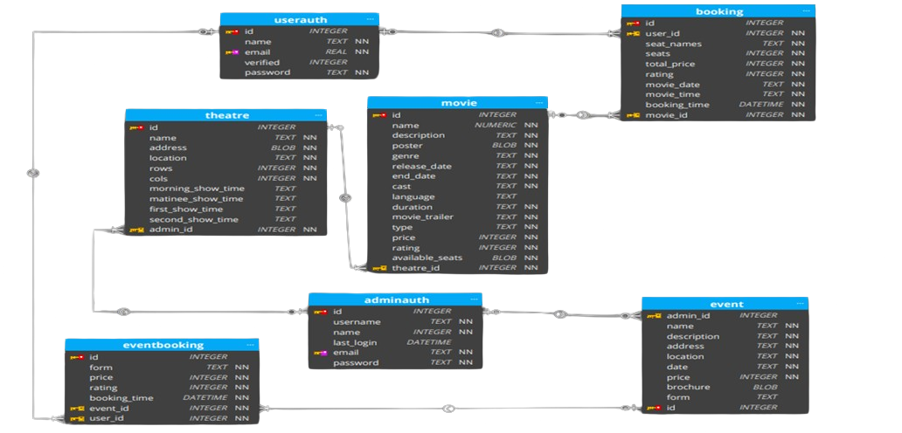

Figure.1 Database Schema

**Screen Shots:**

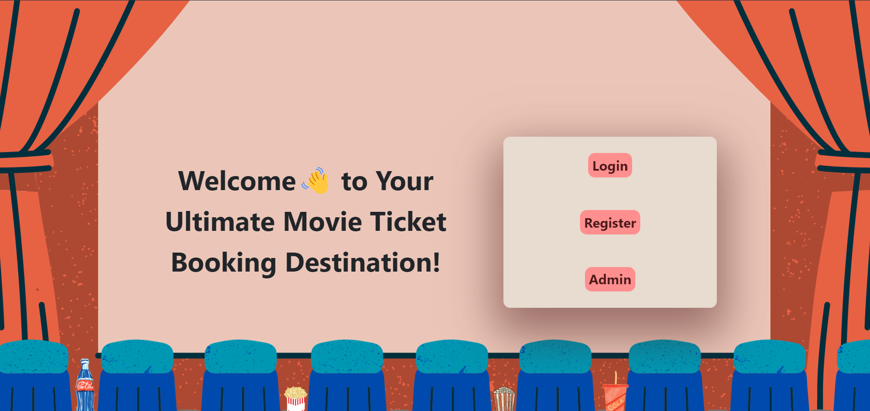

Figure.2: Landing Page

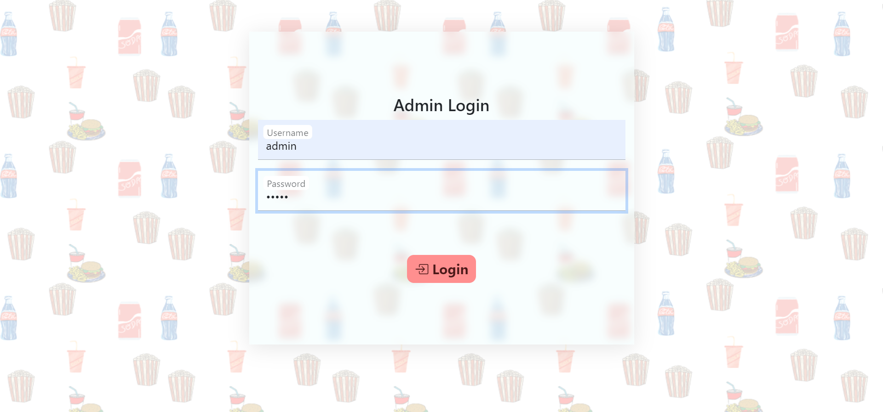

Figure.3: Admin Login Page

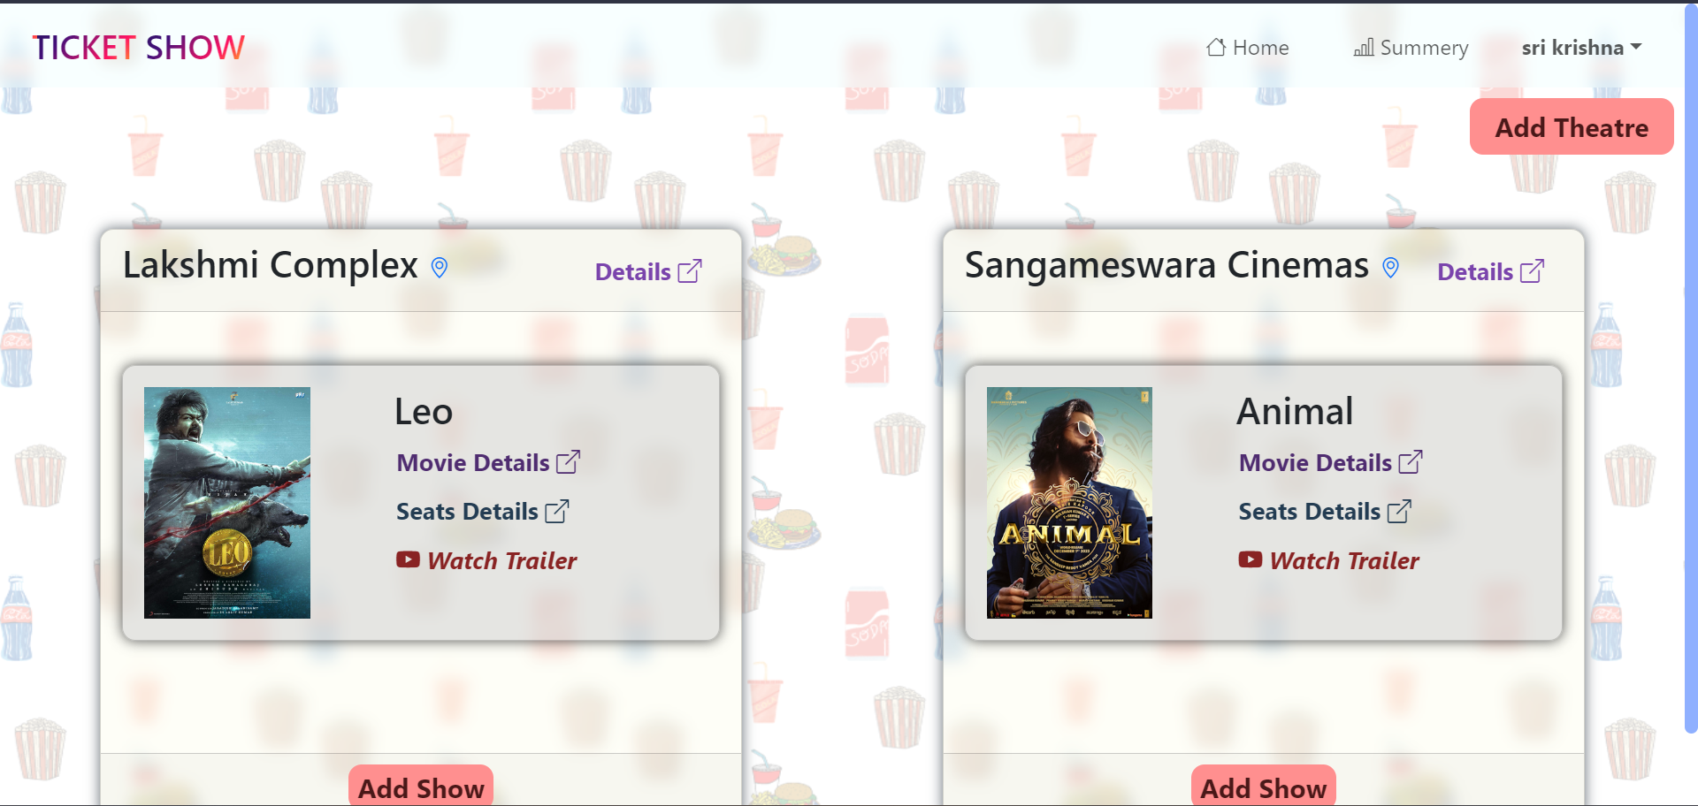

Figure.4: Admin Home Page

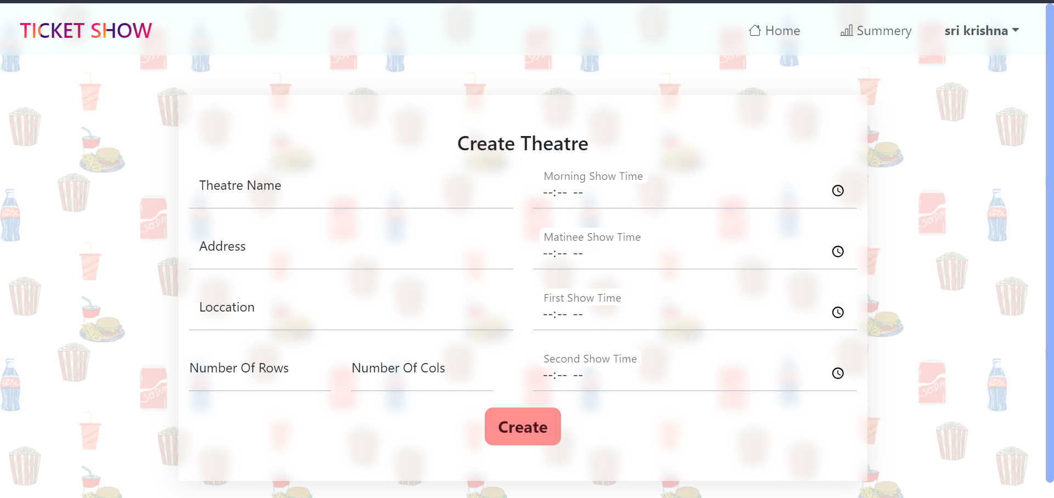

Figure.5: Create Theatre Page

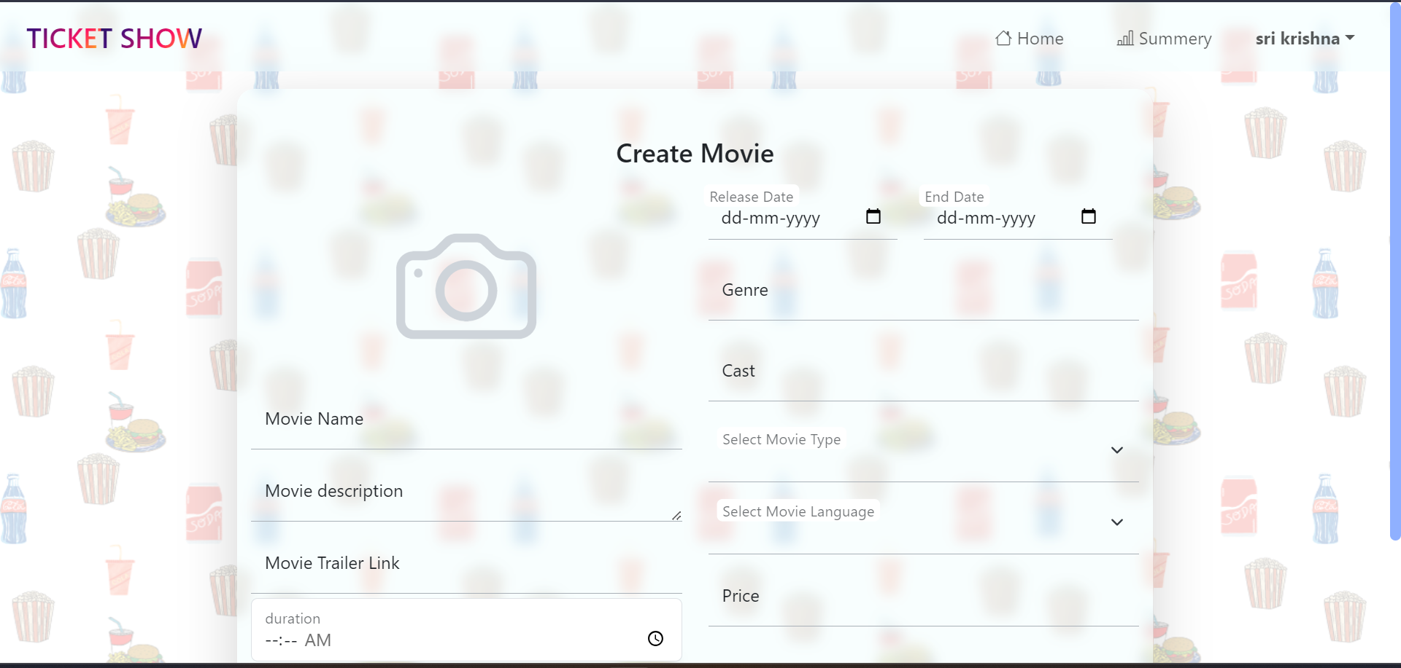

Figure.6: Create Movie Page

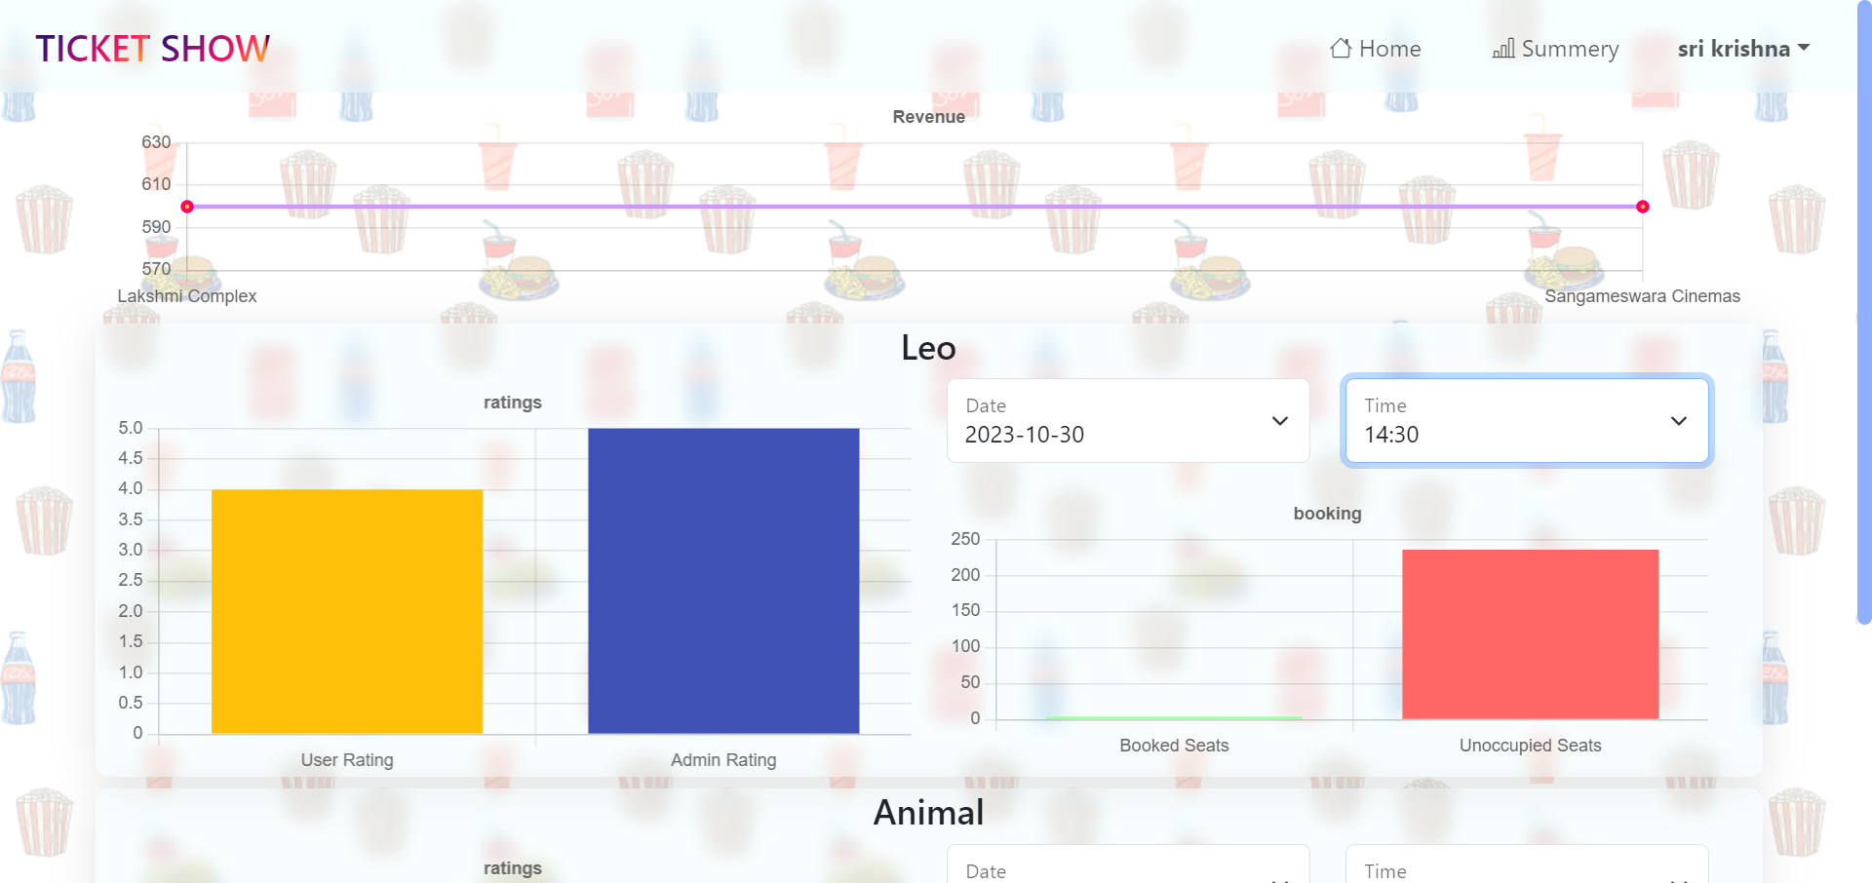

Figure.7: Admin Summery Page

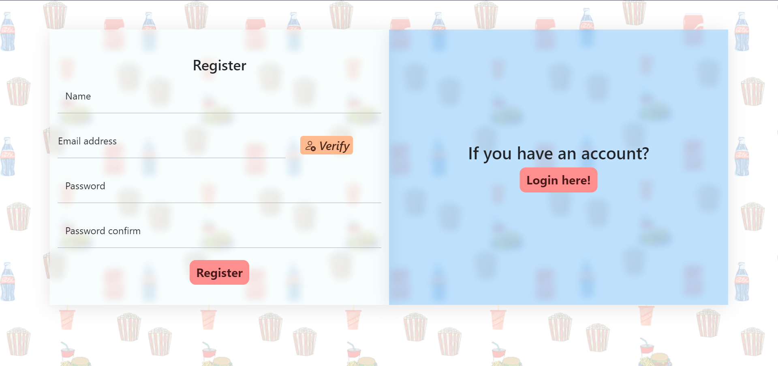

Figure.8: User Register Page

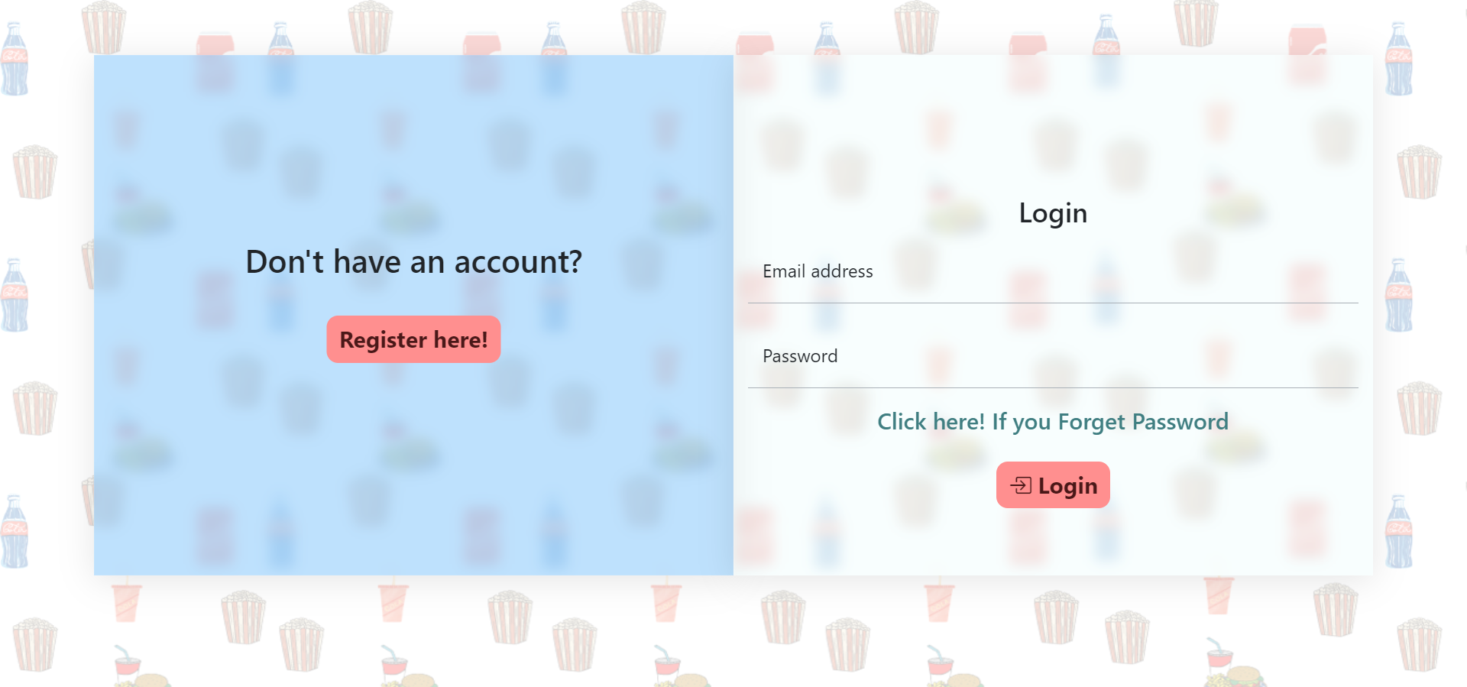

Figure.9: User Login Page

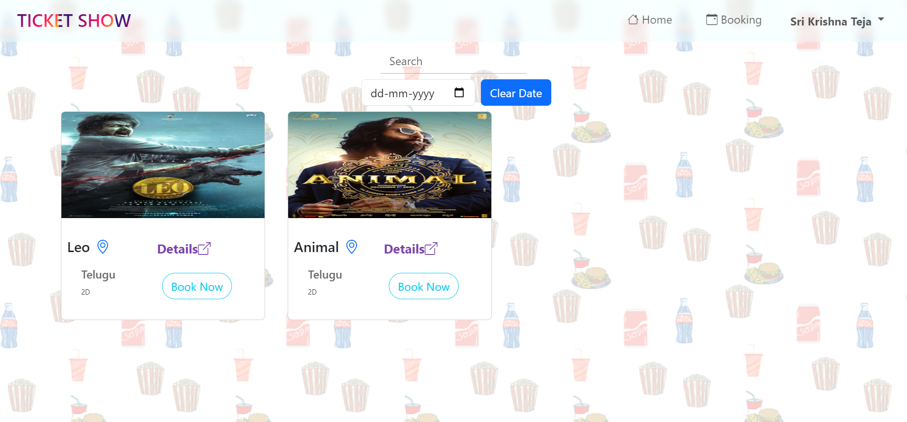

Figure.10: User Home Page

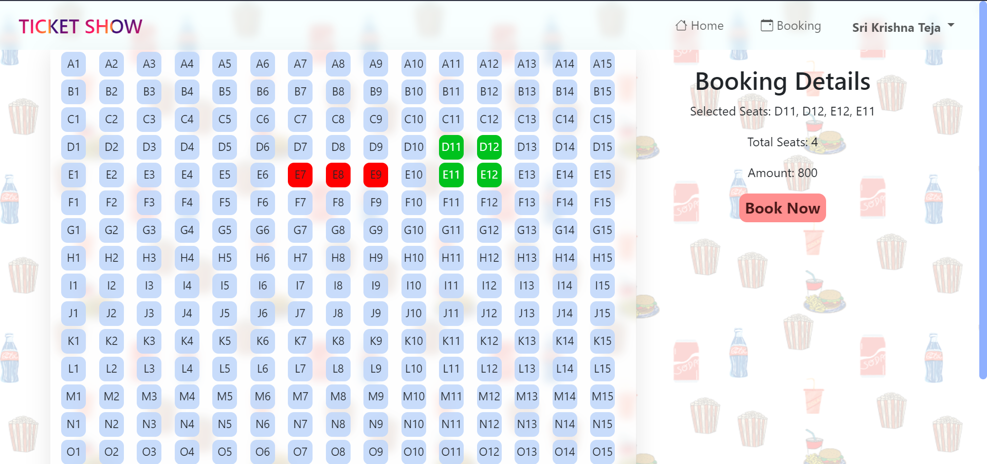

Figure.11: Booking Page

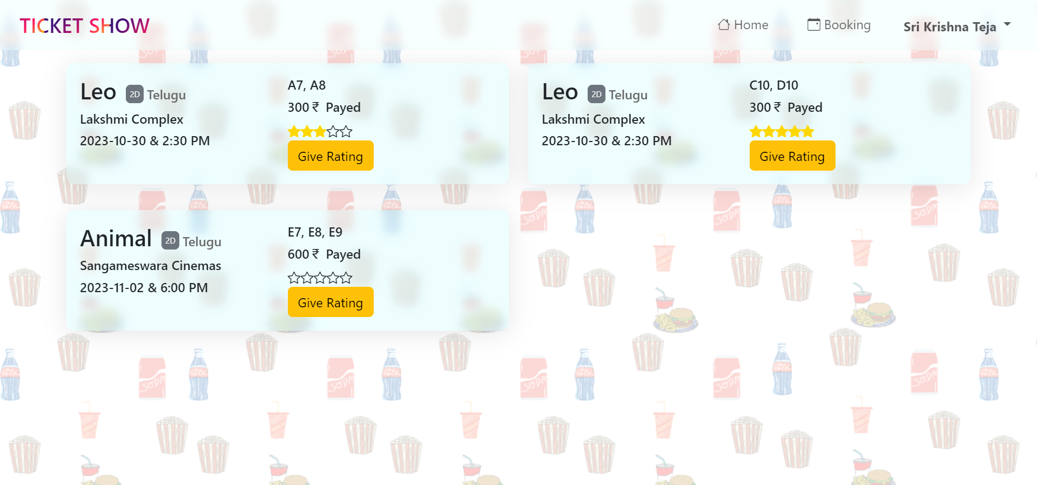

Figure.12: Booking Details Page

**CHAPTER-5:**

**Constraints**

The development of the Multi-User Movie Ticket Booking Application involved managing various constraints that influenced design and decision-making. These constraints, while posing challenges, ultimately contributed to the project's successful development. Here are the details of the constraints:

**a) Accessibility:**

**Constraint**: The application must ensure that it is usable by people with disabilities and complies with accessibility standards and guidelines.

**Impact on Design**: The design and development of the user interface had to consider accessibility features, such as screen reader compatibility, keyboard navigation, and alternative text for images. This constraint influenced the design of an inclusive and user-friendly interface.

**b) Code:**

**Constraint**: The quality and maintainability of the software codebase, including adherence to coding standards, readability, and best practices, is essential.

**Impact on Design**: The development team had to follow coding standards and best practices to maintain a clean, readable, and maintainable codebase. This constraint ensured that the application's code was of high quality and could be easily maintained and extended.

**c) Constructability:**

**Constraint**: The ease of building and deploying the software, taking into account available resources and technology constraints, is a critical factor.

**Impact on Design**: The development process considered the hardware and software resources available for deployment. The application architecture was designed to be deployable on common server environments, ensuring ease of implementation.

**d) Cost:**

**Constraint**: The project involved budgetary limitations, including development costs, infrastructure expenses, and ongoing operational expenses.

**Impact on Design**: The project's cost constraints influenced decisions related to technology stack selection, cloud services, and infrastructure. Choices were made to optimize costs

**e) Extensibility:**

**Constraint**: The application needed to be designed with a focus on the ability to easily expand or enhance the software to accommodate future needs and features.

**Impact on Design**: The architecture of the application was designed to be modular and extensible, allowing for the addition of new features and functionality in response to changing user requirements.

**f) Functionality:**

**Constraint**: The application had to meet specific features and capabilities to satisfy user and business requirements.

**Impact on Design**: The design and development process prioritized the implementation of essential features, such as movie ticket booking, role-based access control, and reporting features. Meeting these requirements was critical for the application's success.

**g) Interoperability:**

**Constraint**: The application must be capable of working seamlessly with other systems, applications, and technologies.

**Impact on Design**: Standardized APIs and data exchange formats were employed to ensure interoperability with other systems and services. This constraint facilitated integration with third-party platforms and services.

**h) Legal Considerations:**

**Constraint**: Compliance with legal regulations, licenses, and intellectual property rights is a critical aspect of the project.

**Impact on Design**: The development process included legal reviews and compliance checks to ensure that the application adhered to data privacy regulations, intellectual property rights, and licensing requirements.

**i) Maintainability:**

**Constraint**: The ease of maintaining and updating the software over its lifecycle, including code changes and bug fixes, is a key consideration.

**Impact on Design**: The design prioritized code modularity, documentation, and clear version control practices to ensure that the application could be efficiently maintained and updated over time.

**j) Marketable:**

**Constraint**: The application's appeal to its intended audience and its potential for success in the market are critical for its success.

**Impact on Design**: User experience design and marketing considerations were integrated into the application's design to make it appealing and engaging for users. The design aimed to create an attractive and user-friendly platform.

**k) Schedule:**

**Constraint**: The project defined specific project timelines and deadlines, ensuring that the software was delivered within the specified timeframe.

**Impact on Design**: The project management approach involved efficient task scheduling and milestone tracking to meet the established deadlines. The design process prioritized features according to the project timeline.

**l) Standards:**

**Constraint**: The application must adhere to industry-specific or organizational standards and guidelines for software development.

**Impact on Design**: The development process ensured compliance with industry standards such as security standards, accessibility guidelines, and coding standards. Adhering to these standards improved the quality and security of the application.

**m) Sustainability:**

**Constraint**: The application design needed to consider the environmental and resource impact, promoting eco-friendly and resource-efficient development.

**Impact on Design**: The design included considerations for optimizing resource utilization, such as server efficiency and power consumption. While not directly related to ecological sustainability, these practices contributed to resource efficiency.

**n) Usability:**

**Constraint**: The application's interface and user experience must be user-friendly and intuitive for its intended users.

**Impact on Design**: The design prioritized user interface design principles to create a user-friendly and intuitive experience. Extensive user testing and feedback collection helped refine the interface for usability.

These constraints, while presenting challenges, played a crucial role in shaping the design, development, and management of the Multi-User Movie Ticket Booking Application. By addressing these constraints, the project achieved a balance between user needs, technical requirements, and resource limitations, ultimately delivering a high-quality and user-friendly platform.

**CHAPTER-6:**

**Cost and Sustainability Analysis**

The Multi-User Movie Ticket Booking Application incorporates economic, environmental, and social sustainability considerations into its development. These aspects impact design choices, resource utilization, and the application's long-term viability. Here are the details of the cost and sustainability analysis:

**6.1 Economic Considerations:**

**Cost-Effective Technology Selection**: The project aimed to optimize costs by selecting cost-effective technologies and open-source solutions. This decision reduced initial development costs and ongoing operational expenses.

**Cloud Services**: The use of cloud services for hosting and scalability allowed for cost-effective infrastructure management. Cloud resources could be scaled up or down as needed, minimizing infrastructure costs.

**Scalability for Cost Efficiency**: The application's architecture was designed to be scalable, ensuring that resources are used efficiently. This scalability prevents overprovisioning of resources and minimizes costs during periods of low demand.

**Operational Efficiency**: The use of Redis for caching and performance optimization reduced server load and operational costs by improving data retrieval efficiency.

**Monetization Opportunities**: The project considered monetization opportunities through features like premium booking services, targeted advertising, and partnerships with cinemas. These potential revenue streams can offset development and operational costs.

**6.2 Environmental Considerations:**

**Resource Efficiency**: The design and architecture of the application considered resource efficiency. By optimizing code and infrastructure, the application reduces energy consumption, contributing to environmental sustainability.

**Cloud Resource Management**: The use of cloud services also supports environmental sustainability by allowing efficient resource allocation. This prevents overconsumption of energy and resources during peak usage.

**Reduced Paper Consumption**: By providing an online platform for booking movie tickets, the application indirectly reduces the need for physical tickets and printed materials. This minimizes paper consumption and waste.

**Eco-Friendly Hosting**: Hosting providers with a commitment to green energy and sustainable data centres were considered to minimize the application's carbon footprint.

**6.3 Social (Equity) Considerations:**

**Accessibility**: The application was designed with accessibility in mind to ensure that it is inclusive and usable by people with disabilities. This promotes social equity by providing equal access to entertainment for all.

**Multilingual Support**: To cater to diverse audiences, the application supports multilingual content, making it accessible to users from different language backgrounds.

**User-Friendly Interface**: The user interface design focuses on creating a user-friendly and intuitive experience. This ensures that users, regardless of their technological proficiency, can easily access and use the application.

**Affordability**: Keeping the application cost-effective and providing options for discounted tickets or promotions promotes social equity by making movie entertainment accessible to a broader audience.

**Transparency**: The application provides transparent pricing, showtime information, and user reviews to help users make informed choices. This promotes equity by ensuring that users have access to essential information.

By considering these economic, environmental, and social factors, the Multi-User Movie Ticket Booking Application demonstrates a commitment to sustainability and responsible development. The project's design and operational choices are aligned with the goal of providing a cost-effective, resource-efficient, and inclusive platform for movie ticket booking while minimizing its environmental impact.

**CHAPTER-7:**

**Conclusions / Summary**

The development of the Multi-User Movie Ticket Booking Application has been a significant endeavor that aimed to revolutionize the way moviegoers’ access and book movie tickets. The project successfully achieved its objectives, resulting in a comprehensive platform that enhances the movie-going experience, ensures secure user interactions, and simplifies theatre and movie management. Here's a detailed summary of the project's activities and results:

**7.1 Solution Proposed:**

The project proposed a multi-user movie ticket booking application that addresses the limitations of traditional ticket booking processes. It introduced a user-friendly interface that caters to regular users and administrators, offering role-based access control to distinguish between Admin, Store Manager, and Customer roles. The application's core features include secure user authentication, efficient theatre management, customizable movie schedules, booking capabilities, export options, reporting features, alerts, and performance enhancements. The application leverages a technology stack that includes Vue.js, Flask, HTML, CSS, Bootstrap, Redis, Celery, Chart.js, JWT, and SQLite.

**7.2 Main Results:**

The project's main results include:

* A responsive and intuitive user interface that simplifies movie ticket browsing and booking.
* Secure user authentication with role-based access control (RBAC) for different user roles.
* Efficient management of theatre details with support for multilingual content.
* Customizable movie schedules to keep users informed about showtimes.
* A robust booking system that allows users to reserve multiple tickets for various movies.
* Export options for theatre details via CSV for administrators and users.
* Reporting features that provide insights into booking trends and movie performance.
* Scheduled backend jobs for data synchronization, email alerts, and reminders.
* Performance optimizations using caching techniques to enhance the user experience.

**7.3 Significance of the Project:**

The Multi-User Movie Ticket Booking Application is significant in several ways:

* It offers a modern and user-friendly alternative to traditional movie ticket booking processes, improving the overall movie-going experience for users.
* The application's role-based access control ensures that administrators can efficiently manage theatres and movie schedules while users can easily book tickets.
* Its performance optimizations provide a responsive and efficient platform for users, reducing wait times and improving operational efficiency.
* By adhering to security and accessibility standards, the application promotes a secure and inclusive environment for all users.
* The project's consideration of economic, environmental, and social sustainability factors aligns with responsible and ethical software development practices.

**7.4 Comparison with Other Existing Solutions:**

Compared to other existing solutions, the Multi-User Movie Ticket Booking Application distinguishes itself through its combination of features, including role-based access control, performance optimizations, and sustainability considerations. While traditional ticket booking systems still exist, the project offers a more efficient and user-friendly alternative that leverages modern technology.

The application's focus on accessibility, sustainability, and transparency further sets it apart from many existing solutions. By providing multilingual support, adhering to accessibility standards, and promoting eco-friendly practices, the project aims to be a socially responsible and inclusive platform.

**7.5 Future Directions:**

The project's modular architecture allows for future expansions and enhancements. Potential future directions include:

* Integration with additional cinema chains and independent theatres.
* Further optimization for mobile and tablet devices to enhance the mobile booking experience.
* Enhanced analytics and reporting features to provide more in-depth insights for administrators.
* Integration with loyalty programs and partnerships with cinemas for promotional offers.
* Continuous improvement of sustainability practices to further reduce the application's environmental footprint.

In conclusion, the Multi-User Movie Ticket Booking Application is a milestone in the entertainment industry, offering a user-friendly and efficient platform for movie enthusiasts. With its focus on security, accessibility, sustainability, and performance, it represents a comprehensive solution that aligns with modern software development practices and responsible business operations.

**CHAPTER-8:**

**References**

* W3C. (2023). HTML 5.1 Recommendation. World Wide Web Consortium. Retrieved September 2, 2023, from https://www.w3.org/
* W3C. (2023). Cascading Style Sheets Level 3 Recommendation. World Wide Web Consortium. Retrieved September 2, 2023, from https://www.w3.org/
* Vue.js. (2023). Vue.js Documentation. Vue.js.org. Retrieved September 2, 2023, from https://vuejs.org/guide/introduction.html
* Flask. (2023). Flask Documentation. Pallets Projects. Retrieved September 2, 2023, from https://palletsprojects.com/
* SQLite. (2023). SQLite Documentation. SQLite Global Development Group. Retrieved September 2, 2023, from https://www.sqlite.org/docs.html
* Redis. (2023). Redis Documentation. Redis.io. Retrieved September 2, 2023, from https://redis.io/docs/
* Celery. (2023). Celery Documentation. Celery Project. Retrieved September 2, 2023, from https://docs.celeryq.dev/en/stable/userguide/tasks.html